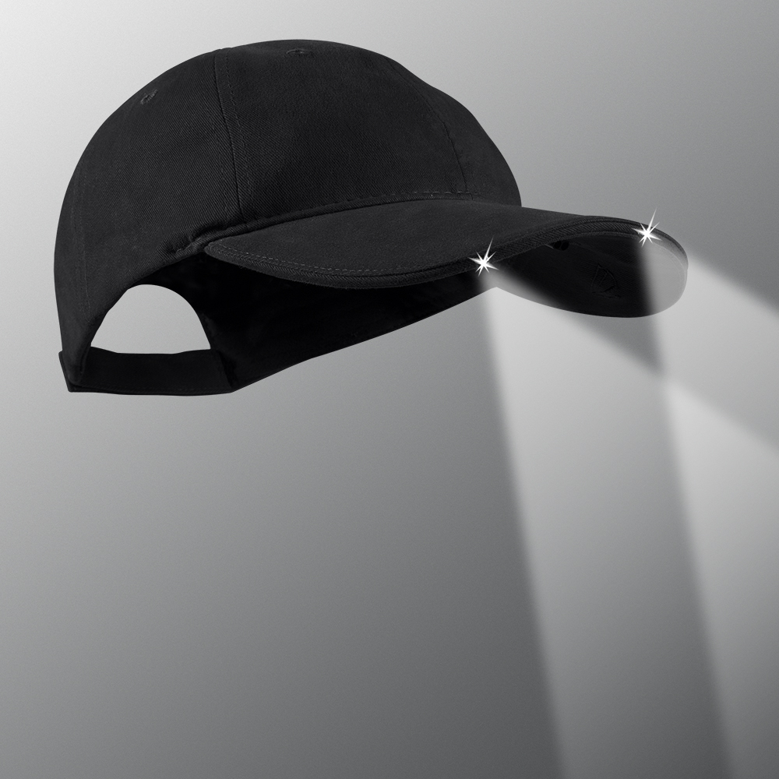
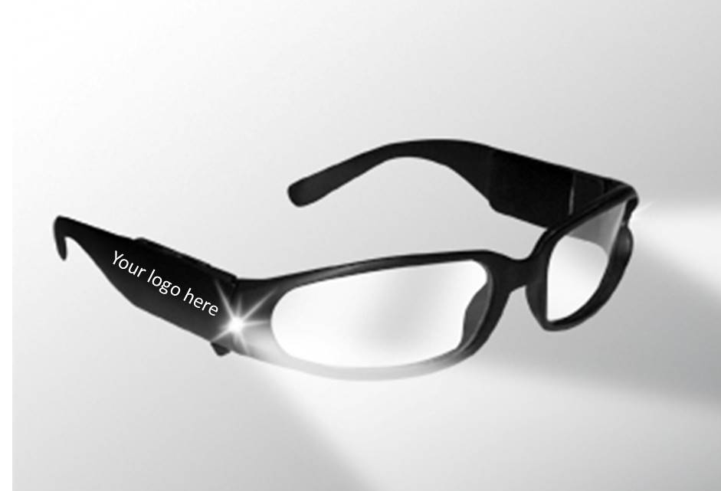
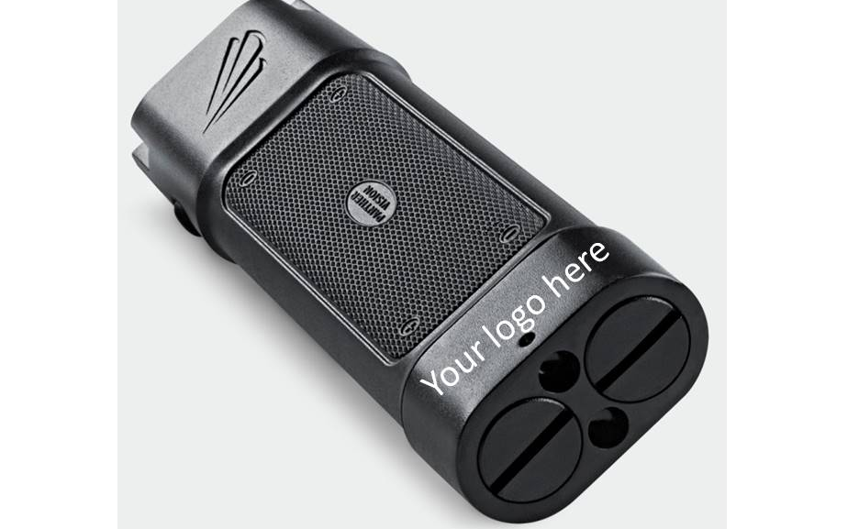
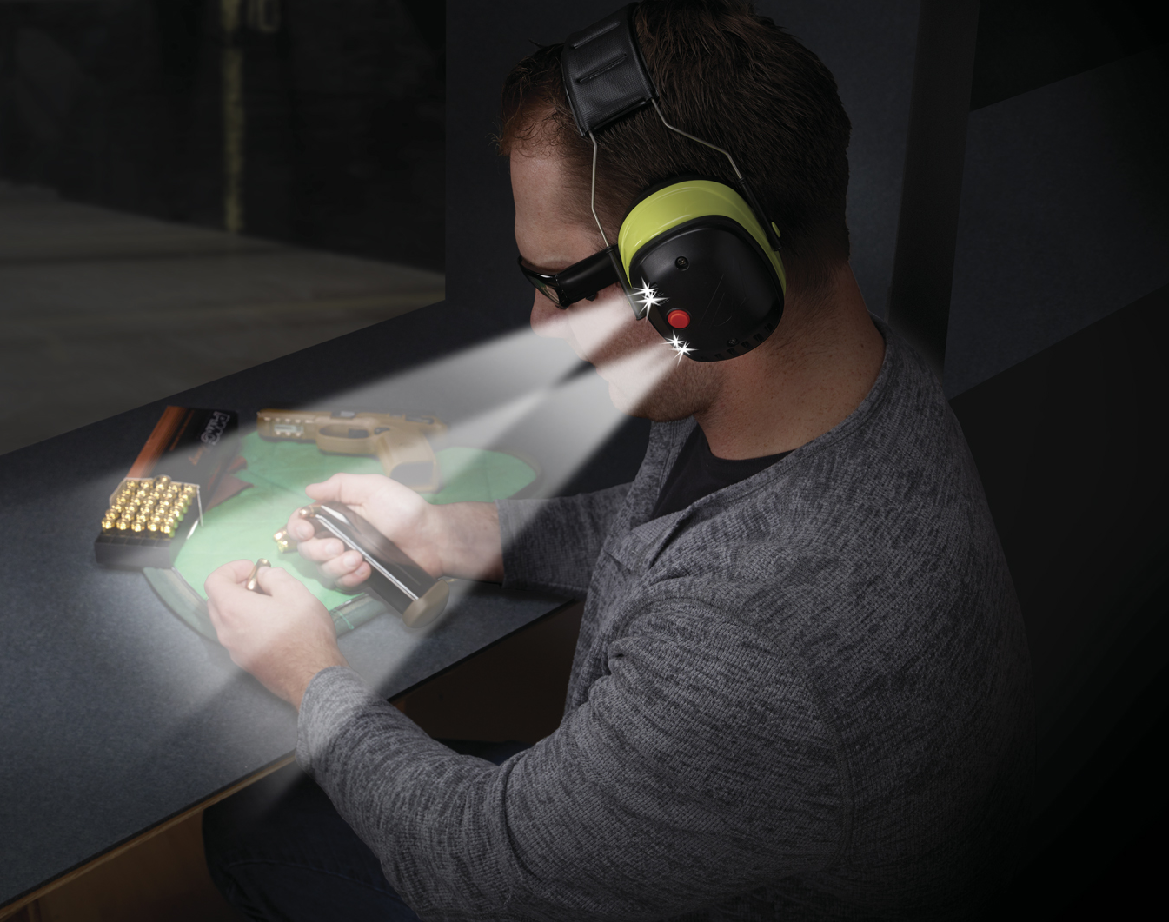
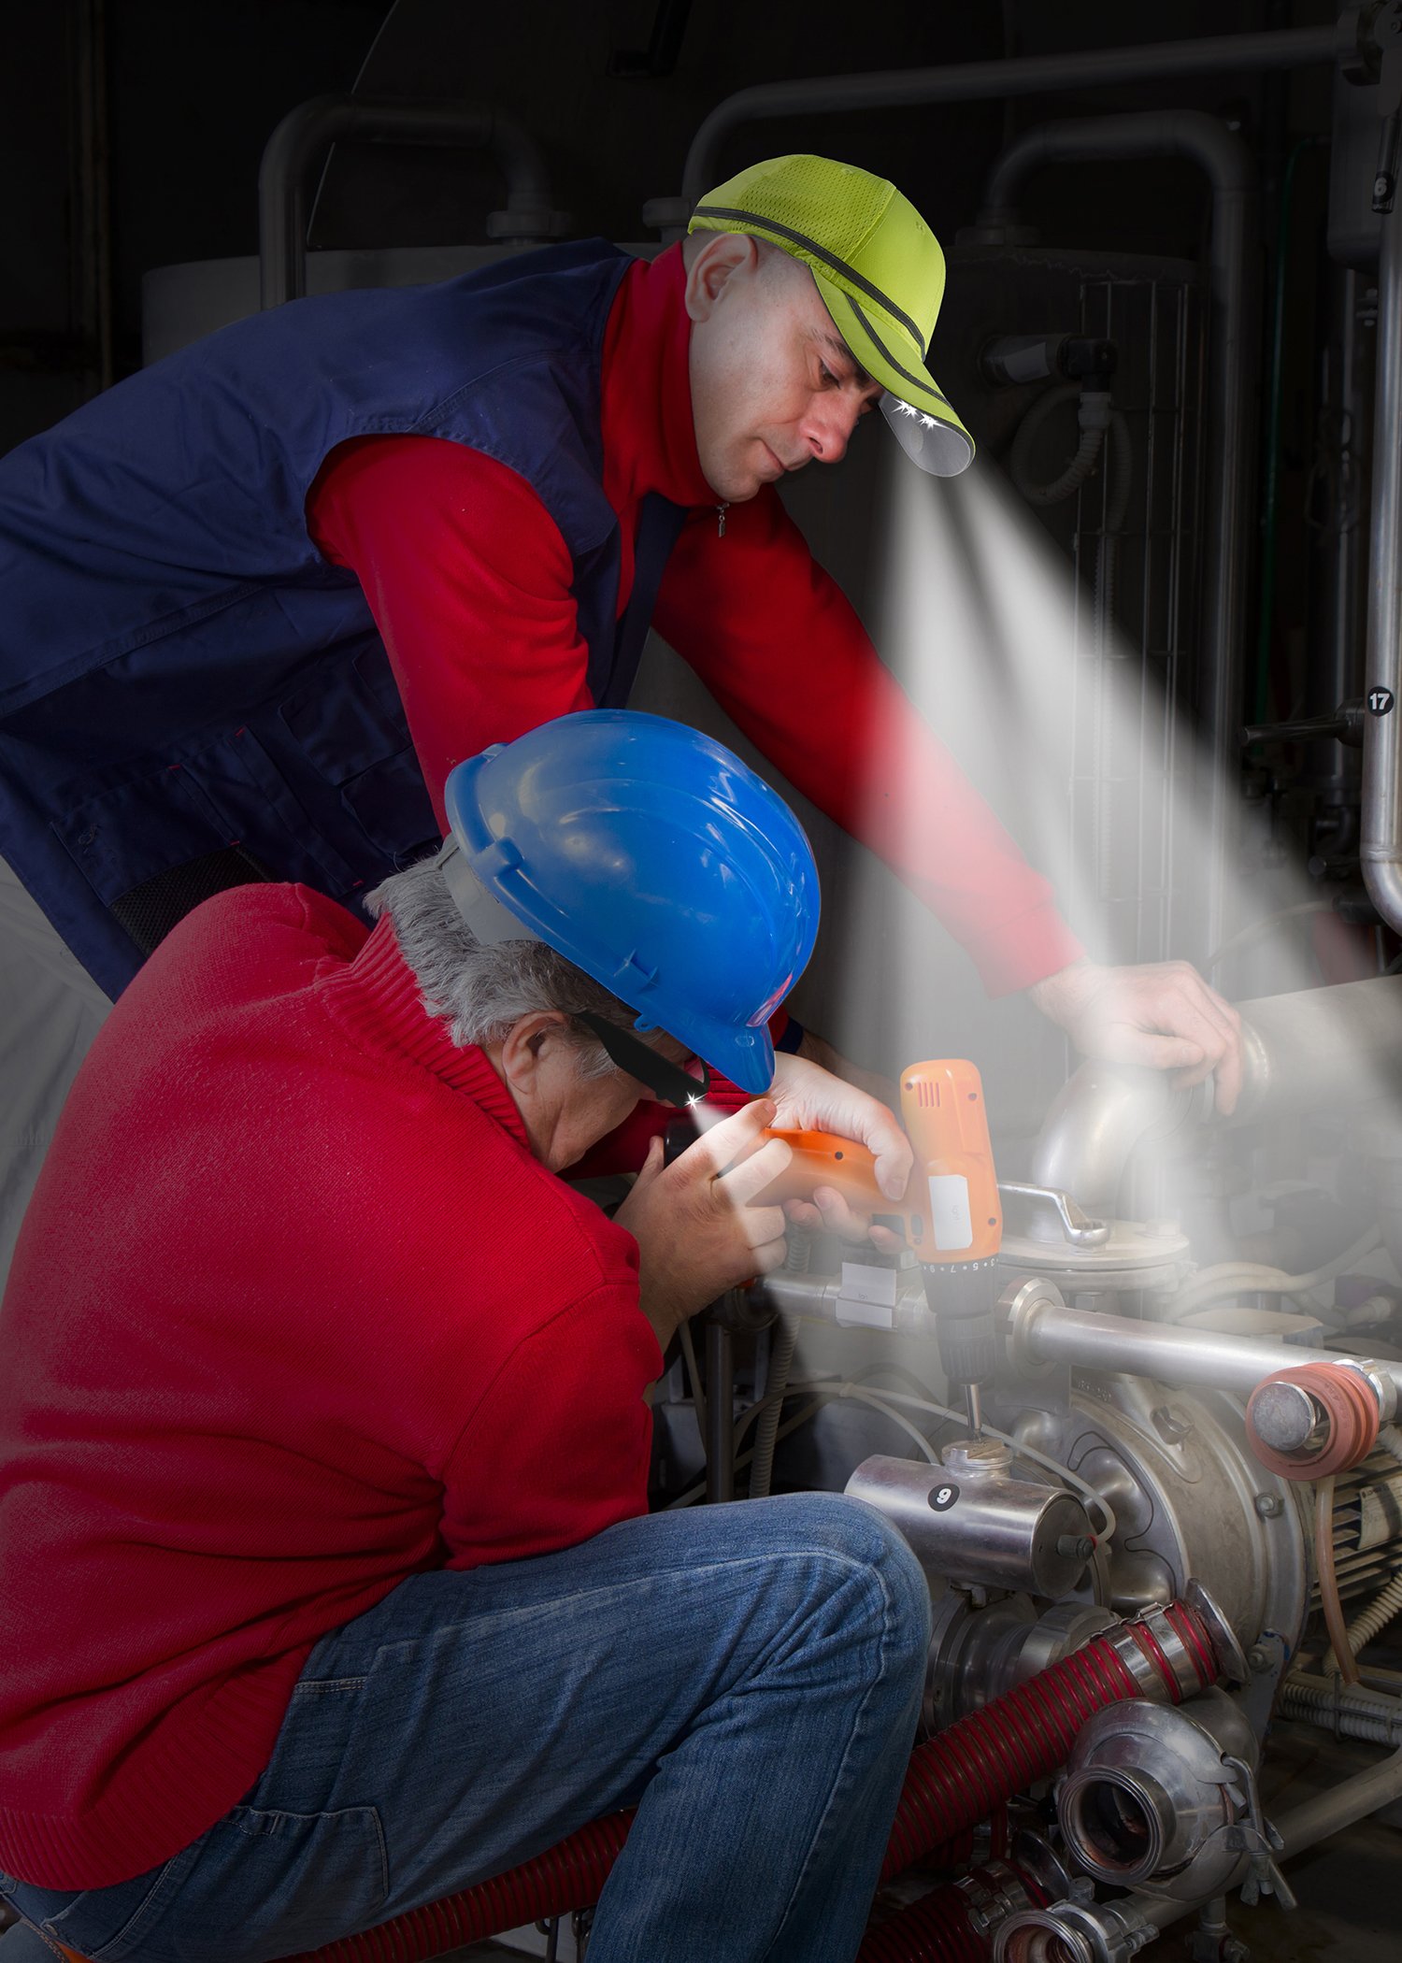

VISIT OUR WEBSITE WWW.PANTHERVISIONPROMO.COM
TO SEE THE FULL LINE OF LIGHTED PRODUCTS
OR CALL 847.783.5900 x 116 FOR MORE INFORMATION

VISIT OUR WEBSITE WWW.PANTHERVISIONPROMO.COM
TO SEE THE FULL LINE OF LIGHTED PRODUCTS
OR CALL 847.783.5900 x 116 FOR MORE INFORMATION

VISIT OUR WEBSITE WWW.PANTHERVISIONPROMO.COM
TO SEE THE FULL LINE OF LIGHTED PRODUCTS
OR CALL 847.783.5900 x 116 FOR MORE INFORMATION

ASI 75825 SAGE 68668 PPAI 318255

VISIT OUR WEBSITE WWW.PANTHERVISIONPROMO.COM
TO SEE THE FULL LINE OF LIGHTED PRODUCTS
OR CALL 847.783.5900 x 116 FOR MORE INFORMATION

VISIT OUR WEBSITE WWW.PANTHERVISIONPROMO.COM
TO SEE THE FULL LINE OF LIGHTED PRODUCTS
OR CALL 847.783.5900 x 116 FOR MORE INFORMATION

CAPLIGHT 2000 SERIES
As low as $31.99 with 1 color/1 location logo (s)
As low as $11.84 with 5,000 stitch logo (s)
LIGHTSPEC SAFETY GLASSES
As low as $16.23 with 1 color/1 arm logo (s)
As low as $36.68 with 1 color imprint (s)
FLATEYE
Unround flashlight

Add your logo here
SAFETY FIRST
Everyone wants to be safe.

Do you have jumper cables
and a first aid kit in your car? Just in case.

Or first aid kit, candles, water, blanket,
radio etc. in your home?

CONSIDER OUR LIGHTED
PRODUCTS FOR SAFETY

Great promotional item for
insurance companies, car dealers,
mortgage brokers and others

Easily add your customers logo with
pad printing, embroidery or heat transfer and give them a product that WORKS.

